CIS2166 Data Analytics

By: Christopher Diaz Montoya
Student ID: 24707686

Module Lecturers: Huaizhong (Sam) Zhang and Yannis Korkontzelos

Contents
Table of Figures 3
Practical Session Log – Week 1 4
Bibliography – Week 1 7
Practical Session Log – Week 2 8
Bibliography – Week 2 13
Practical Session Log – Week 3 13
Loan data analysis 21
Introduction 21
Does your gender make a difference? 21
Does your educational background make a difference? 21
Does your credit score make a difference? 22
Does your property location make a difference? 22
23
Other findings 23
Summary 24
Bibliography - week 3 24
Practical Session Log – Week 4 25

Table of Figures
Figure 1 - Gender & Loan Status 21
Figure 2 - Gender & Pay 21
Figure 3 - Education & Loan Status 21
Figure 4 - Education & Pay 22
Figure 5 - Credit score & Loan Status 22
Figure 6 - Credit score & Pay 22
Figure 7 - Property location & Loan Status 22
Figure 8 - Property location & Pay 23
Figure 9 - Loan Status & Pay categorised 23
Figure 10 - Pay and Loan amount 23
Figure 11 - Heatmap 24

Practical Session Log – Week 1
Name: Christopher Diaz Montoya Date: 27/01/2022 Time: 18:00
Briefly describe the purpose of this session:
This was an introduction to the module explaining what would be learnt and an introductory to the python programming language to familiarise ourselves with spyder and jupyter notebooks.
Describe the procedure(s) you followed to complete today’s session:
(Images added in the weekly reflective logs for all exercises, as logs were not formal nor was a formal report required for each week, image labelling wasn’t included and at the end of each problem explanation are the images).
In this session, the coursework for this module was explained and the first practice session was given out with some easy exercises to complete. The stages of data analysis were also explained.
In the seminar, we had to do some basic python exercises on both spyder and jupyter notebooks on multiple skills we learned last academic year. I mainly used jupyter for all the exercises as I prefer IDE. I have also included a screenshot of the output of each exercise after the breakdown.
- First it asked us to add 2 integers, this was easy as it was used a lot last academic year, I stored the numbers in 2 variables and then added the 2 variables with print(num1+num2).
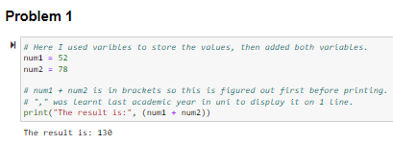
- The second task asked out to print out a string 4 times, so I created a for loop which looped 4 times as the range of 0 - 4 was given for the loop, this was learned last academic year. For each loop “Hello, world!” was printed, this resulted in hello world being printed out four times.
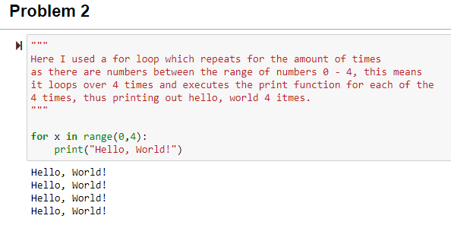
- The third asked us to print out the twinkle little star song in a specific format. As it was long, I used \ to create a new line in the code so each line was not too long, I also added \n for whenever I needed a new line in the song and \t for where indents were required, this was familiar from a module from last semester, so no new learning was required.
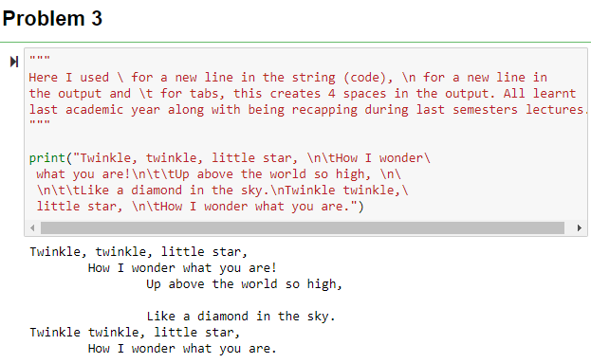
- The fourth asked us to amend some code so that the randomly generated password has a lower and upper character, a number, and a special character. Here some new learning was required, and a random library and a string, digit, and punctuation library were looked for to see if they existed to make the assignment easier, the random and string library were found and imported. A function for the user choice was made, the try-except exception handling method was used as the try-catch was learned for a C# programming module and I wanted to learn how to use it in python, this was used so that if the user accidentally inputs a letter or decimal, it does not break the code, and a recursive function call was used so the user can try again, this was learned in C# module and learned how to use in python. Next, the password length was stored in a variable, then letters, digits, and punctuation were stored for random choice in the charChoice variable, the password variable automatically had 4 random characters added each time, 1 uppercase, 1 lowercase letter, 1 digit, and 1 form of punctuation. Then a for loop was created to add the remaining characters from the charChoice variable to the password variable. Finally, this was converted to a list for ease of shuffling to then convert back to a string and print the randomly generated password. The .shuffle() method was learned for this with having learned the .join() method from last semester.
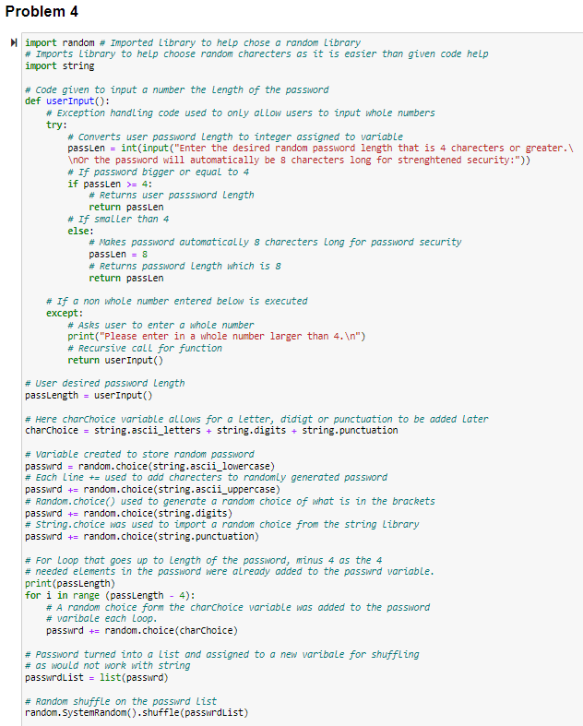
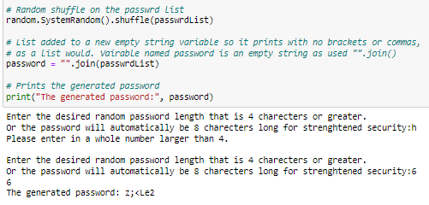

- The challenge problem was to generate an acronym from a sentence, with given hints to use split and indexing, these were learned last academic year so no prior research was needed. The user input for a sentence was stored and split on the spaces with .split(“ “). Then a counter variable was created which would be used later to inform the user which word the letter comes from. Finally, a for loop was used to loop over each word in the list and to print the first character in each word, this in code, was done by printing the first character for each item in the list by printing index 0. At the end of the loop, the counter increases by 1 to show the user the first letter of the next word.
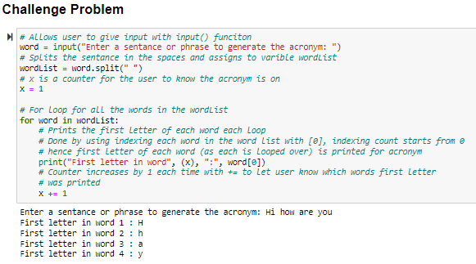

If valid, state the reasons you have not been able to complete your work:
N/A
Please comment on today’s session:
It was a good warm-up session to start the module with the basics to refresh us this semester and be ready for what is to come. It was fun and easy, I did not need to do much learning as other techniques were learned from other programming languages, this is helping me realise the essence of all programming languages is similar. Thus, hopefully decreasing the learning curve for any programming language.
Some further work could have been done with error handling for example in the challenge, errors occur if double spacing is used for sentences or white space is left at the end, these errors could have been removed with the use of try-except, this was not added due to wanting to move onto other work and getting it done quickly, 10-20 minutes could have been set aside to make the code more robust but was not.
Recapping loops, lists, functions, indexing, and slicing was not needed as these were thoroughly recapped last semester to not need to relearn how to use them. This was a vast improvement from last semester allowing me to complete the tasks quicker.

Bibliography – Week 1

JAMES, J., 2017. Python: RECURSION Explained [online video]. Available from: https://www.youtube.com/watch?v=wMNrSM5RFMc [Accessed 27 January 22].
PYTHONDOCS., N/A. random – Generate pseudo-random numbers [online]. Available from: https://docs.python.org/3/library/random.html [Accessed 27 January 22].
PYTHONDOCS., N/A. string – Common string operations [online]. Available from: https://docs.python.org/3/library/string.html [Accessed 27 January 22].
W3SCHOOLS., N/A. Python Random shuffle() Method [online]. Available from: https://www.w3schools.com/python/ref_random_shuffle.asp [Accessed 27 January 22].
W3SCHOOLS., N/A. Python Try Except [online]. Available from: https://www.w3schools.com/python/python_try_except.asp [Accessed 27 January 22].

Practical Session Log – Week 2
Name: Christopher Diaz Montoya Date: 03/02/2022 Time: 19:45
Briefly describe the purpose of this session:
The purpose of this session was to teach us more about python data types and control flow, along with teaching us how to input data sets and read them in a table or a graph from a csv file and text file, it was also about learning and introducing the panda’s library.
Describe the procedure(s) you followed to complete today’s session:
During the lecture, we went over quite a bit such as primitive data types such as integers, bools & strings. Along with lists, tuples, and dictionaries, we also went over control flow, I/O, functions, pandas library, and modules.
In the seminar, we had to do some python exercises on our IDE, on multiple skills we learned over last year, and from the lecture and seminar slides. The slides and a handout given to us taught us about NumPy arrays and how to plot our first graphs and make our first graphs from external files.
- The first problem asked us to find certain numbers in a range, so I used a for loop to set the range and then used an if statement and a conditional statement within to ensure only the numbers that met the criteria were printed. I then made sure they were printed in a comma-separated sequence on a single line.
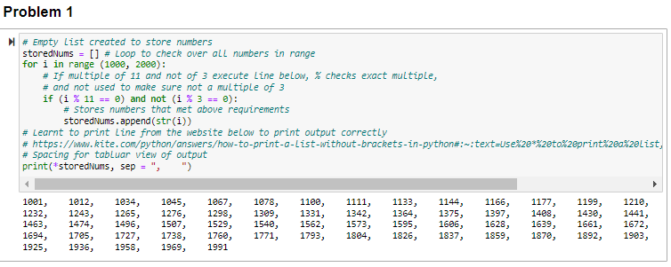
- The second problem asked to capitalise whatever a user inputted, again I used a for loop to iterate over each character in the sentence. I used .capitalize() to capitalise each letter and added it to an empty string variable, once the loop was completed the variable storing the capitalised word/sentence would be printed.
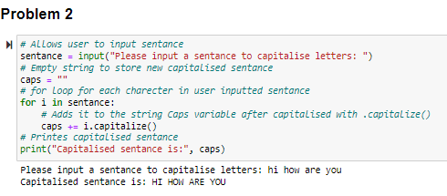
- Problem 3 asked for a function that converts integers to strings, I created a function that casts the inputted value to an int and then back to a string and finally prints it out. I also checked the data type to ensure it was a string with type(). Error handling was also used to not let the code break if a user inputted a decimal or a string. Recursion was used to allow the user to try again, this was learned last week.
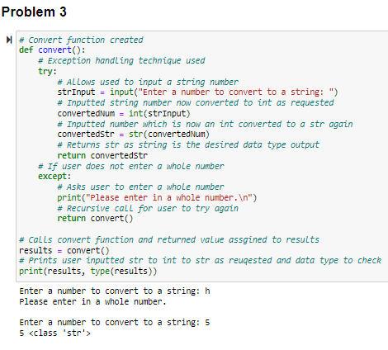
- Problem 4 I needed to recap and google the itertools library to create every possible outcome with itertools and assigned the right words to the right variable so that I could print the desired outcome, this was done with lists and ensuring the subject, verb and object were printed in the correct order.
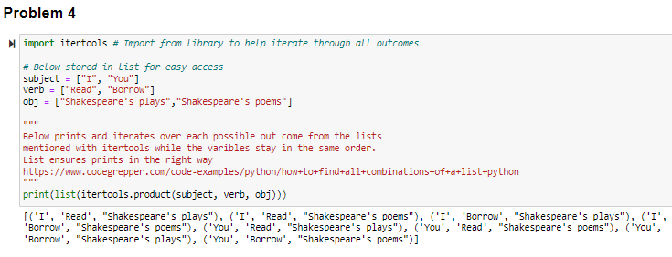
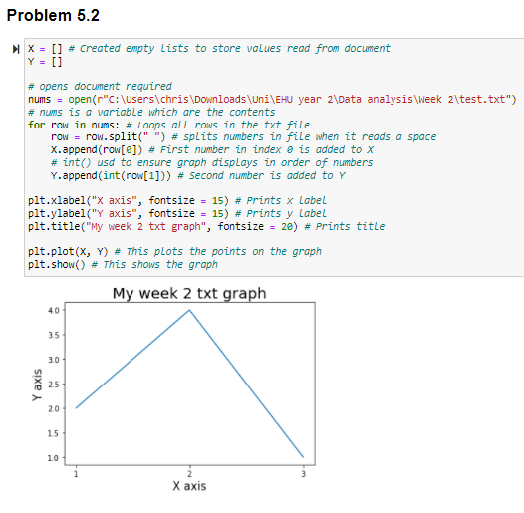
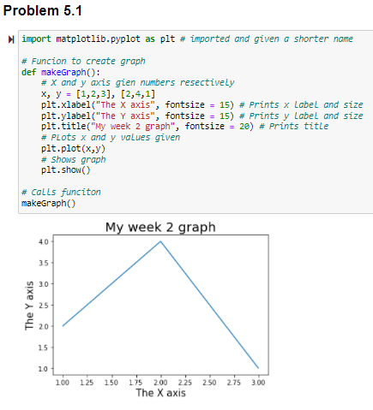
- Problem 5.1 was plotting to plot a graph, we learnt this in lesson, and I remembered as well how to assign values to plot x and y on a line graph along with having remembered how to give the axis and graph a title and change small bits in the graph. I used matplotlib.pyplot for this and created the graph in a function. Part 2 then asked us to do the same but for the graph to be made from data in a text file. I used a for loop for this so it would iterate over every value in the text document, I split the 2 columns in the text document and assigned them to X and Y to get the desired graph. I did not use a function for problem 5.2 and this could have been done to tidy up the code.

- Problem 6 was to check a series of comma-separated passwords to meet a certain criterion. The user was prompted to input a username to make it feel real, then the series of comma-separated passwords, these were separated on the comma and stored as a list, a checker function checked the passwords met the criteria by using a for loop to loop over all the elements in the list. Within the loop, conditional statements were used to ensure the criteria were met for the passwords to be accepted, and if they were not accepted, then mention the issue. The re library was used to help search if the item matched any in a set.
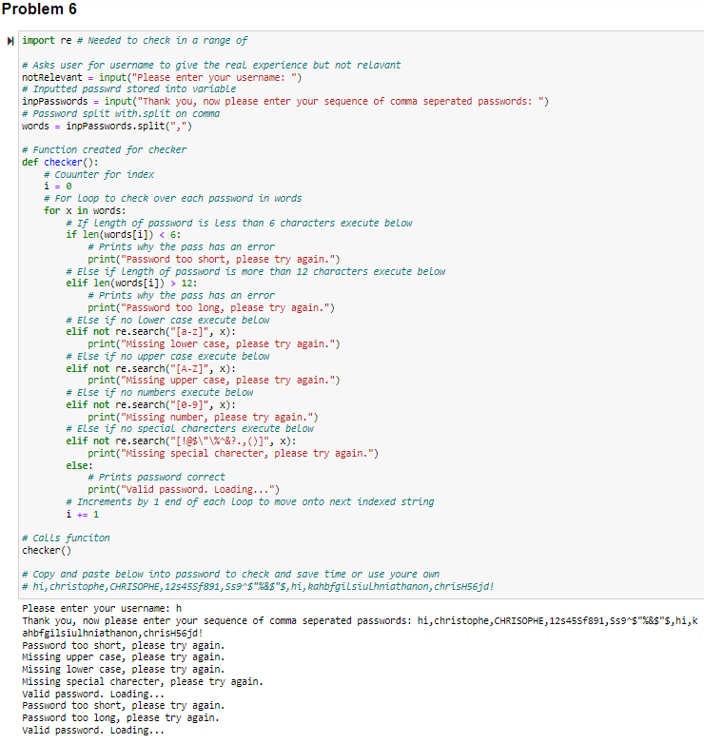
- The challenge problem was to create a rock, paper, scissors game against the computer. The random library was imported and so rock, paper, or scissors could be chosen at random from a list. The user was asked what they wanted to chose, this was stored in a variable. Then the game was written in a function. This function contained conditional statements, one to evaluate if the choice was the same which would be a tie, the following conditional statements contained nested statements, this was learned last academic year. If a user chose rock, then the only two other options left the computer could play would be nested statements and depending on the computer’s choice the code would print and say if the user won or lost. The score was not added but this could have and should have been done by adding 2 counter variables and adding to them respectively depending on the nested conditional statement executed and recursively calling the game with updated counters, printing the updated score each time. At the end of the function, a final conditional statement allowing the user the choice to continue or end the game by asking the user and evaluating their input, to continue the game the function would here be recursively called and to exit just a print function printing thank you for playing.
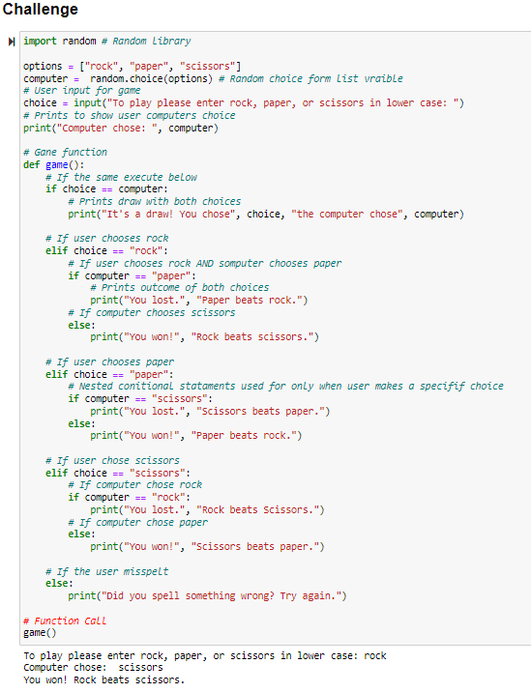
If valid, state the reasons you have not been able to complete your work:
N/A
Please comment on today’s session:
This was a more challenging session than last weeks, with some struggle with problem 6 and the challenge problem at first. To complete them I needed to bullet point on paper and break down the problem into what was needed.
For printing the output on problem one on a coma separated line, I had to revisit my work from last semester although I should have remembered how to do this and try to remember the little things to become a more confident programmer,
I feel like I could have added more functions in almost all the problems to organise the code if I had more time, as seen I included a function for problem 5.1 but not 5.2 as I also wanted to explore different coding styles. This could have been done by dedicating more time on the work.
Exception handling techniques could have been used in the challenge problem along with adding the counter to allow the user to make spelling mistakes and to try again instead of starting the game again.
Overall, I am happy as I can find and implement new libraries such as the re library and happy it has become second nature, this is important as a data scientist, as they have so many large libraries to learn and use. I am also happy that I am more confident with python and the different data types, functions, castings, loops, libraries, plotting graphs (needed to recap opening txt files, should have remembered this form last semester), and using various other python programming techniques without the need to google and recap them. Saying this I should have completed the python challenge even if it was extra work to practice more and incorporate functions and exception handling more often to create more robust code.

Bibliography – Week 2

GEEKSFORGEEKS., 2021. Python – Create Graph from Text File [online]. Available from: https://www.geeksforgeeks.org/python-create-graph-from-text-file/ [Accessed 03 February 2022].
KITE., N/A. 2022. How to print a list without brackets in Python [online]. Available from: https://www.kite.com/python/answers/how-to-print-a-list-without-brackets-in-python#:~:text=Use%20*%20to%20print%20a%20list,set%20sep%20to%20%22%2C%20%22%20 [Accessed 03 February 2022].
PYHTONDOCS., N/A. itertools – Functions creating iterations for efficient looping [online]. Available from: https://docs.python.org/3/library/itertools.html [Accessed 03 February 2022].
PYHTONDOCS., N/A. re – Regular expression operations [online]. Available from: https://docs.python.org/3/library/re.html [Accessed 03 February 2022].

Practical Session Log – Week 3
Name: Christopher Diaz Montoya Date: 10/02/2022 Time: 21:30
Briefly describe the purpose of this session
This week was about learning about how to pre-process data, how to clean and transform it.
Describe the procedure(s) you followed to complete today’s session:
During the lecture, some pre-processing methods and normalization were explained along with how to find and display missing data.
This problem had been attempted before and some improvement was desired for this.
- I started by importing the relevant libraries along with setting a theme for some of the graphs.
- Then I used pandas to import the csv and .head() to check it out.
- The null values and data types in the data frame were then checked.
- Next the percentage of accepted to non-accepted loan applicants were checked.
- Next all the categorical data was put into separate graphs to check relationship to loan status.
- Next all numerical columns were also put into graphs to check relationship to loan status.
- After, some deeper exploration was done to check other relationship such property area and salary, loan amount and applicant income, education and income, income and loan status, credit history and income, and self-employed and income.
- Then all the data was transformed to numerical with get dummies, last time I used one hot encoding one by one, but I am happy this time I could run a loop to convert all needed columns.
- This was followed by the final two graphs which needed numerical data, these were gender and income and gender and loan amount.
- Then, a heat map was used to check the correlation between all the columns against the loan status, this was learned last semester.
- Finally, all the missing values were filled with the mode, this was done as Kumar (2021) explains that skewed data (with a lot of outliers as can be seen in the graph), should have missing data filled with the mode. The data was not fully prepped as was not needed, but is missing outlier detection and removal along with splitting into train and test data.

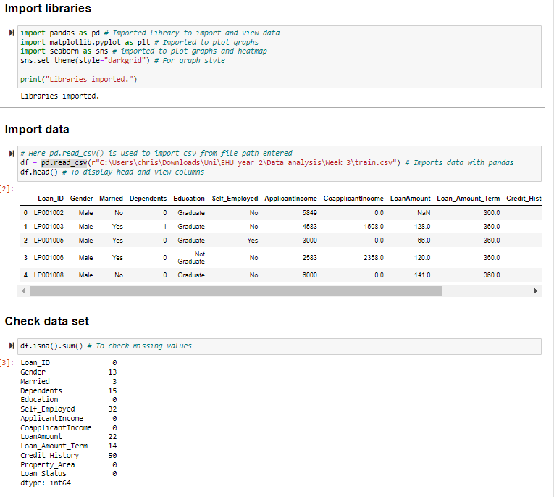
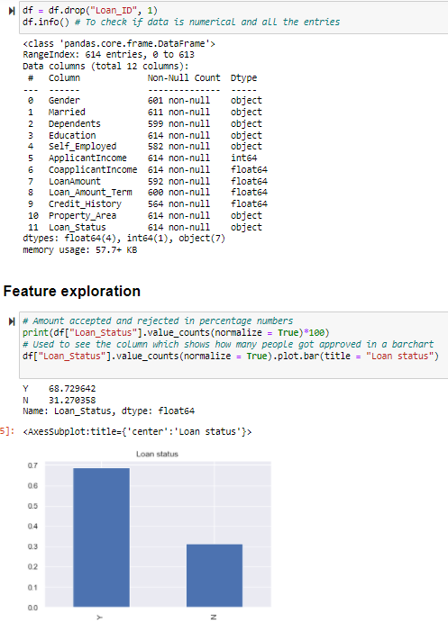
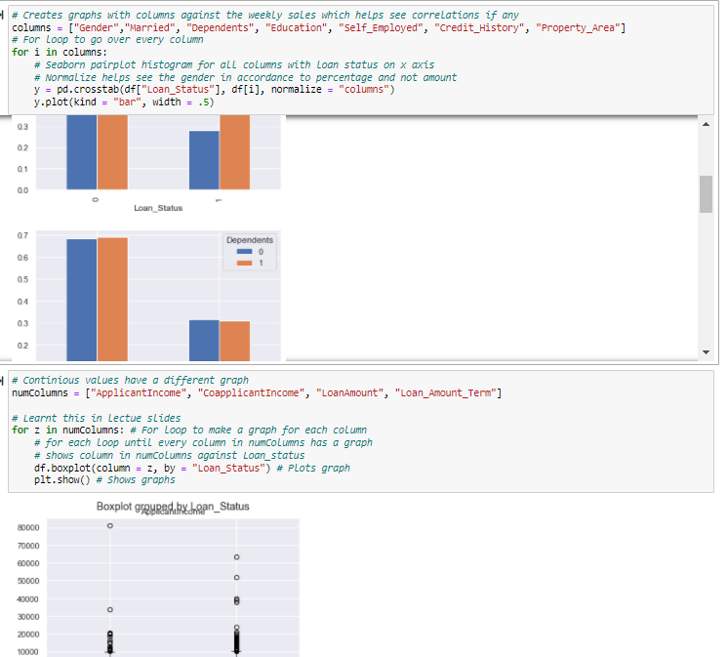
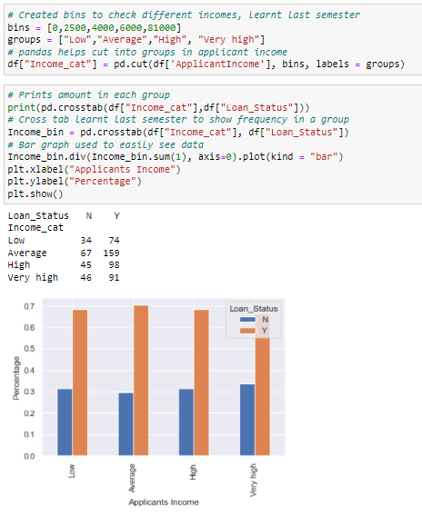
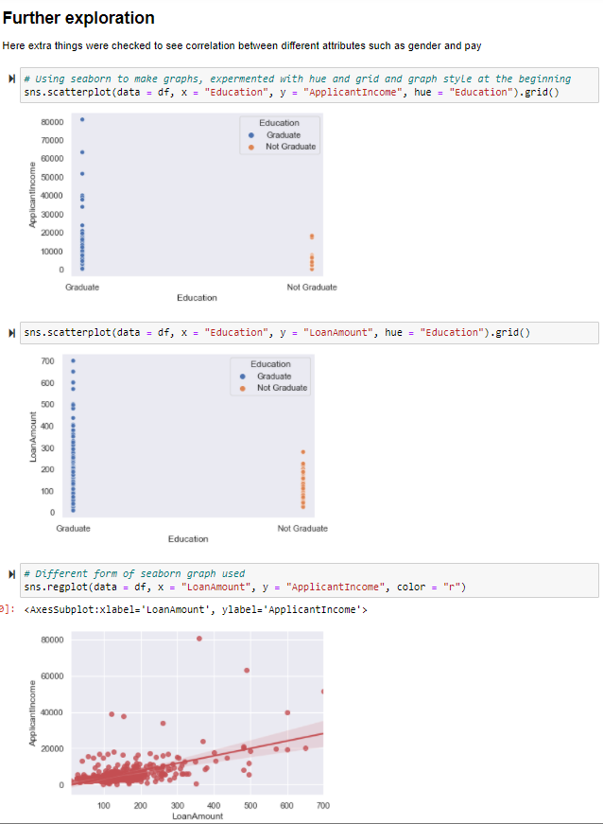
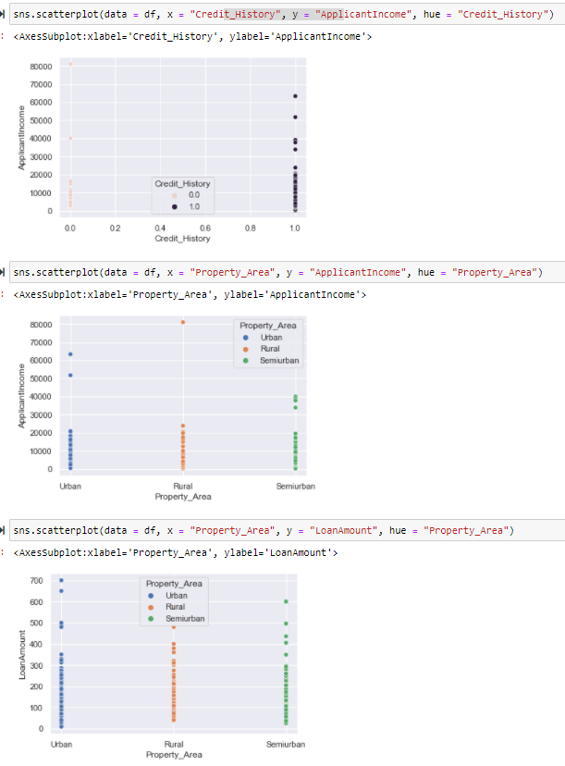
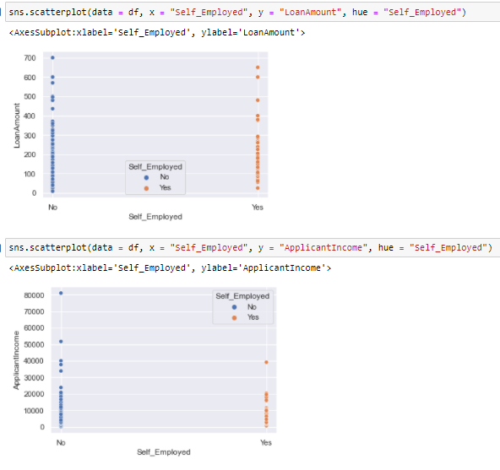
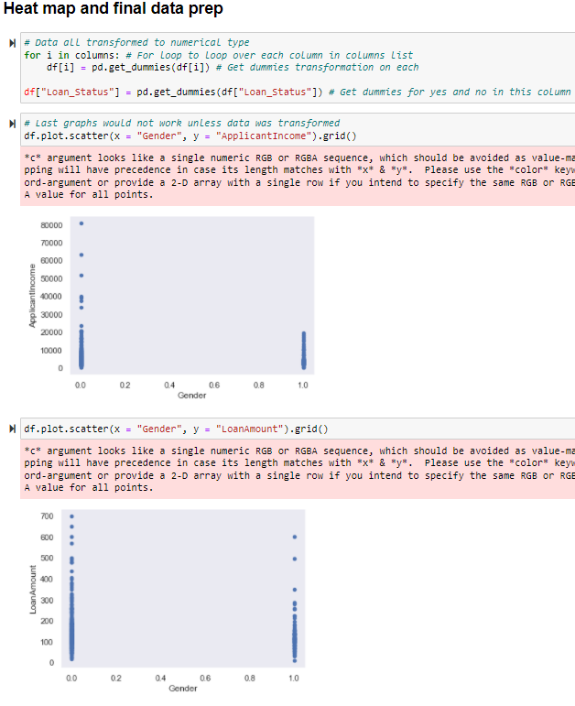
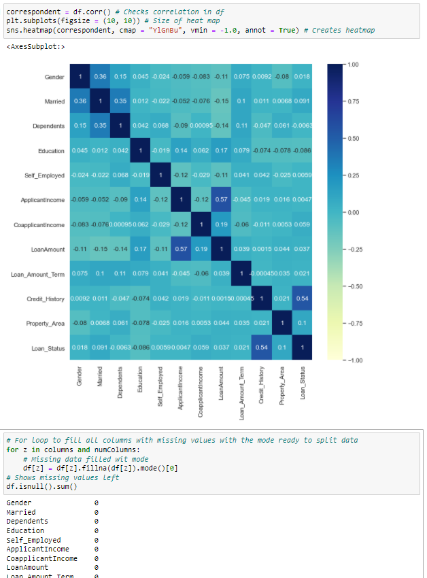
If valid, state the reasons you have not been able to complete your work:
N/A
Please comment on today’s session:
Today’s session was fun, I am feeling more and more like a data scientist, and I love it along with becoming more confident by not needing to google how to code certain things anymore. I am happier with being able to do more complex graphs to analyse data such as heat maps and creating bins in a column to check different ranges of pay. I feel as though I should have done a bit more work to remove the outliers and split the data although was not required, I also feel as though some graphs could have been presented better which would have been done given more time. I am also happy I understand with what to fill missing data in with now.

Loan data analysis

Introduction

This analysis’s aim is to see what factors affect the chance on getting a mortgage. These factors include gender, property location, education, property locations and dependents to name a few. This was done using python to create graphs from the data set provided. The analysis within the report is based on the findings from the graphs created.

Does your gender make a difference?
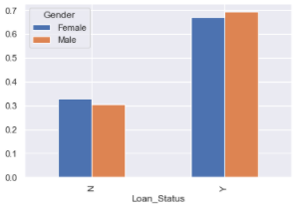
Figure 1 - Gender & Loan Status
Gender does not have much influence in getting a mortgage, saying this, men did get a slightly higher approval rate as shown in Figure 1 - Gender & Loan Status. Looking at Figure 1 - Gender & Loan Status, the reject rate seems to be half that of the approval, thus inferring that there is a 1 in 3 chance of getting rejected.
Next gender pay was analysed to see if this was a reason for lower female approval rates, as shown in Figure 2 - Gender & Pay men had more outliers which earned more, this could be the proof but each outlier should be checked to see if they were approved and make the difference in Figure 1 - Gender & Loan Status.
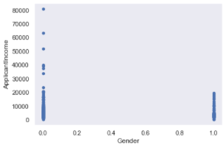
Figure 2 - Gender & Pay

Does your educational background make a difference?
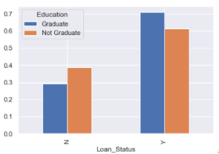
Figure 3 - Education & Loan Status
As show in Figure 3 - Education & Loan Status applicants which graduated were more likely to get approved with a roughly 10% difference.
This was taken further to see if graduates earned more, as shown in Figure 4 - Education & Pay graduates earned both more on average with the highest earning graduate earning 4 times more than the highest non graduate.
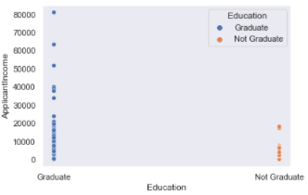
Figure 4 - Education & Pay

Does your credit score make a difference?

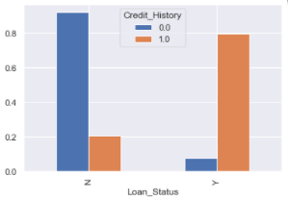
As shown in Figure 5 - Credit score & Loan Status credit score had a high impact on the loan status with a roughly 90% disapproval rate for low credit score applicants. With an 80% approval for applicants with a good credit score. This was checked against income.

Figure 5 - Credit score & Loan Status

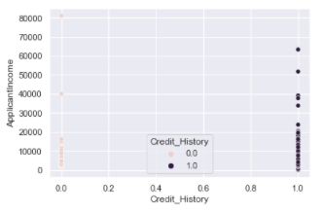
As shown in Figure 5 - Credit score & Loan Status applicants with a better credit score generally had a higher income, this could be further investigated to check the correlation between credit score and education.

Figure 6 - Credit score & Pay

Does your property location make a difference?
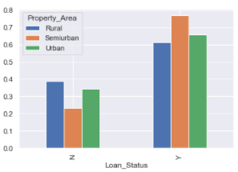
As shown in Figure 7 - Property location & Loan Status semi urban properties had the highest approval rate. This was further explored in Figure 8 - Property location & Pay to see if higher earners preferred semi urban properties, these was a slight increase but not enough to make a deduction. This could be taken further to see if applicants with higher credit scores preferred semiurban properties.
Figure 7 - Property location & Loan Status

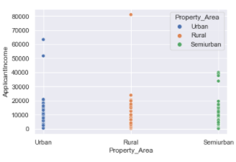
Figure 8 - Property location & Pay

Other findings

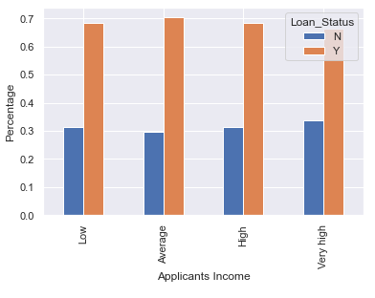
As shown in higher income did not translate to a higher chance of having you loan approved.
Although as shown in Figure 10 - Pay and Loan amount this did increase the loan amount an applicant could receive.

Figure 9 - Loan Status & Pay categorised
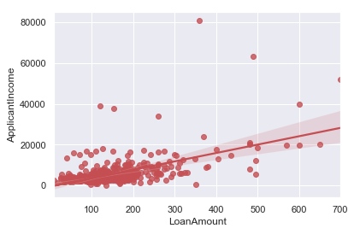
Figure 10 - Pay and Loan amount

Summary

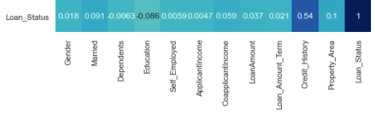
Figure 11 - Heatmap
The findings in Figure 11 - Heatmap confirm what is in the report, the heat map shows the correlation between all the columns and loan status, with number 1 meaning it has the highest possible impact and 0 being the lowest, the highest correlations were:
- Credit History
- Property Area
- Married
- Educational background
The married column was overlooked and had an impact in the approval rate. If an applicant has a good credit score, is a graduate, chooses a property in the suburbs and is married they will have a high chance of being approved for the loan.

Bibliography - week 3

BROWNLEE, J., 2014. Rescaling Data for Machine Learning in Python with Scikit-Learn [online]. Available from: https://machinelearningmastery.com/rescaling-data-for-machine-learning-in-python-with-scikit-learn/ [Accessed 10 February 2022].
DATACAMP., 2021. Python Seaborn Cheat Sheet [online]. Available from: https://www.datacamp.com/blog/python-seaborn-cheat-sheet [Accessed 10 February 2022].
JOURNELDEV. 2 East Ways to Normalize data in Python [online]. Available from: https://www.journaldev.com/45109/normalize-data-in-python#comments [Accessed 10 February 2022].
KUMAR, A., 2021. Python – Replace Missing Values with Mean, Median & Mode [online]. Available from: https://vitalflux.com/pandas-impute-missing-values-mean-median-mode/ [Accessed 10 February 2022].
MOFFITT, C., 2018. Pandas crosstab explained [online]. Available from: https://pbpython.com/pandas-crosstab.html [Accessed 10 February 2022].
Up data science., 2020. Machine learning features engineering: label ending vs one-hot encoding (using Scikit-learn) [online video]. Available from: https://www.youtube.com/watch?v=mHkdcA-zyYE [Accessed 10 February 2022].

Practical Session Log – Week 4
Name: Christopher Diaz Montoya Date: 18/02/2022 Time: 5:00am
Briefly describe the purpose of this session:
This was an exam styled lecture, with multiple coding tasks to complete.
Describe the procedure(s) you followed to complete today’s session:
The session was divided into 2 parts, we had to do multiple problems and send them to the tutor for marking.
Some of the problems required quick googling or checking over my note to remember how to complete them but overall, I managed to do most exercises without the need for help which I was happy with.
(I have not included images as I must rush to work and only saw we had to add week 4 lab book in now, I have sent al the screenshots of the exercises to Sam for double checking if needed.)
If valid, state the reasons you have not been able to complete your work:
N/A
Please comment on today’s session:
This session was fun and let us test our abilities, I did all the exercises but one and was happy with that.

